**Lab A27 Group 5**

**SC2002 FYP Management System Setup Instructions:**

**Importing External Libraries**

Step 1:

Click on “Import” to import project.

Step 2:

Under “General”, go to “Existing Projects into Workspace”, then click Next.

Step 3:

Under “Select archive file:”, click on “Browse” and find the downloaded zip file of the project document.

Step 4:

Once done, tick all boxes for projects, then click “Finish”

Step 6:

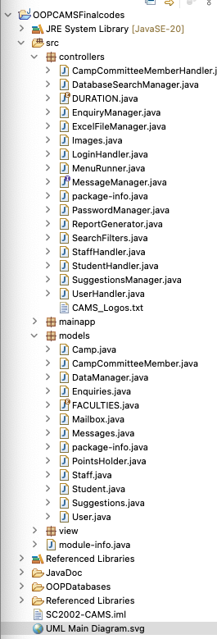

In the highlight files, you will be required to change the file paths to your desktop paths.

Step 7:

To find the file paths, right - click file and click on properties option. You should be able to file path as shown below

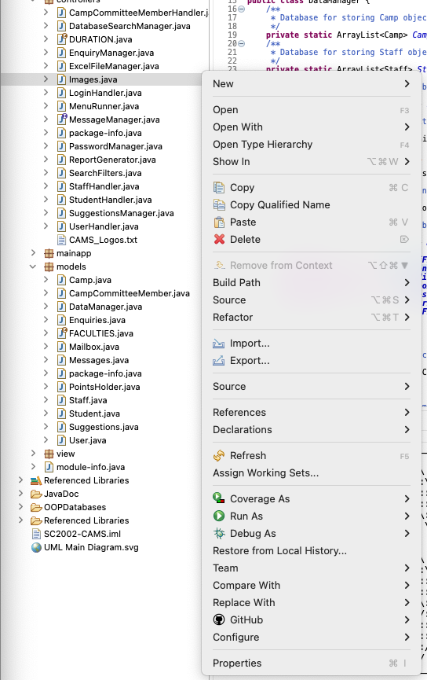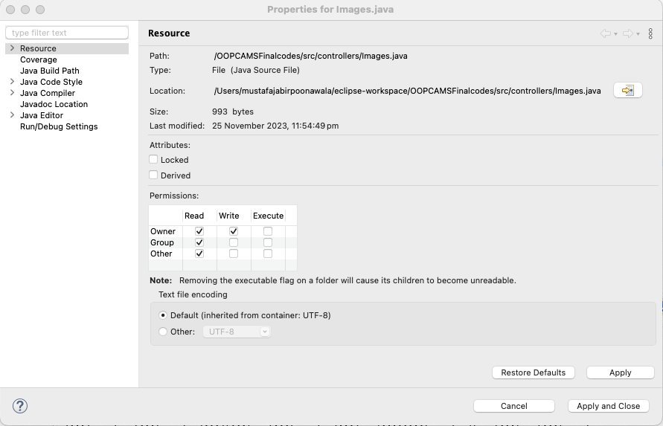

**END**